Tanner Collins, Jaden Johnson, Austin Platt, Brandon Velasquez

CS402 Final Project Proposal

* What is your App and what does it do?
  + Our app is going to be a clicker app, which is a game in which you move forward by accumulating clicks. The more clicks you have, the more money you earn. Along with earning in-game money, you will be able to unlock different achievements, abilities, and other features.
  + This will be a map based clicker app, meaning that what will be ‘clicked’ will be markers on the map. There will be different regions that will be able to be played in. Starting with one region, and unlocking more as you go. You will be able to have different regions being played at the same time, and your level and clicking speed will differ from region to region.
* What are the pieces of the App that you will have to build to make it work?
  + For our project we will extend our map app that we designed for project 3. We will add in many features to that to complete our game. Firstly, we will add in a random clicker that pop ups on the map that you will click, once clicked it will give you a point that can be seen on a scoreboard. We will also have a shop feature where you can possibly buy an auto clicker, increase the clicker count etc. Next, will be to add different levels to our game that show on different parts of the map, for example, the first level can be in the US like Boise and the next level could be in Portugal or another area on the map. We will need to implement and combine all of these aspects, level up, shop, random pop ups for the clicker, scoreboard, etc. apps into our map app to complete our game.
* How will the user interact with it?
  + There is a score at the top, which are the points the user can spend on upgrades.
  + There is a map that has markers that can be clicked to increase the user’s score.
  + There is a map select field that can let the user purchase new maps by clicking on them when they have enough points to purchase it or lets them select a map to move to.
  + There is a list of upgrades that the user can purchase from
  + General idea of what the app could look like:

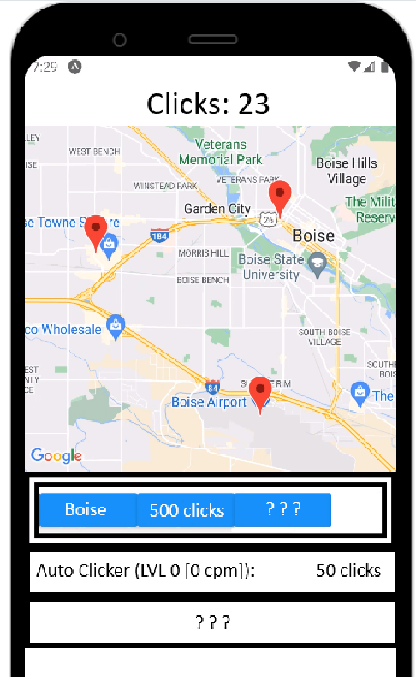

**Schedule for Team Project**

| **Week 1:** | **Nov 6. - 10**: | Sprint 0 - Project Proposal |
| --- | --- | --- |
| **Week 2:** | **Nov 13 - 17:**   * Locking map view * Recognizing when markers are clicked * Click counter * Switching to other map views | Check in  Tanner: Map Lock orientation  Brandon:Locking map view  Austin: Click Counter (done)  Jaden: Recognizing when markers are clicked✅ |
| **Week 3:** | **Nov 20 - 24:** | Thanksgiving Break |
| **Week 4:** | **Nov 27 - Dec. 1:**   * levels   + Boise   + Germany   + France   + Japan   + Hawaii * upgrades   + Autoclicker   + Point multiplier   + Increase marker generation speed | Sprint 1  Tanner:   * Function to generate new markers   Brandon:   * Maybe add the other levels?   Austin:   * Make the click counter functionable (add it’s logic)   Jaden:   * create function to delete markers when they are pressed |
| **Week 5:** | **Dec 4 - 8:** | Check in |
| **Week 6:** | **Dec 11 - 13:** | Sprint 2 / Final Presentation |